- Launch one aws ec2 and install jenkins.

Task 1: Launch one aws ec2 and install jenkins.
Objective:
Launch an AWS EC2 instance and install Jenkins.
Purpose:
To set up Jenkins on an AWS EC2 server for CI/CD automation.
Implementation:
1. Launched an Ubuntu EC2 instance and connected using SSH.
2. Installed Java 21.
3. Installed Jenkins.
4. Started Jenkins using systemctl.
5. Verified the Jenkins service status successfully.

- 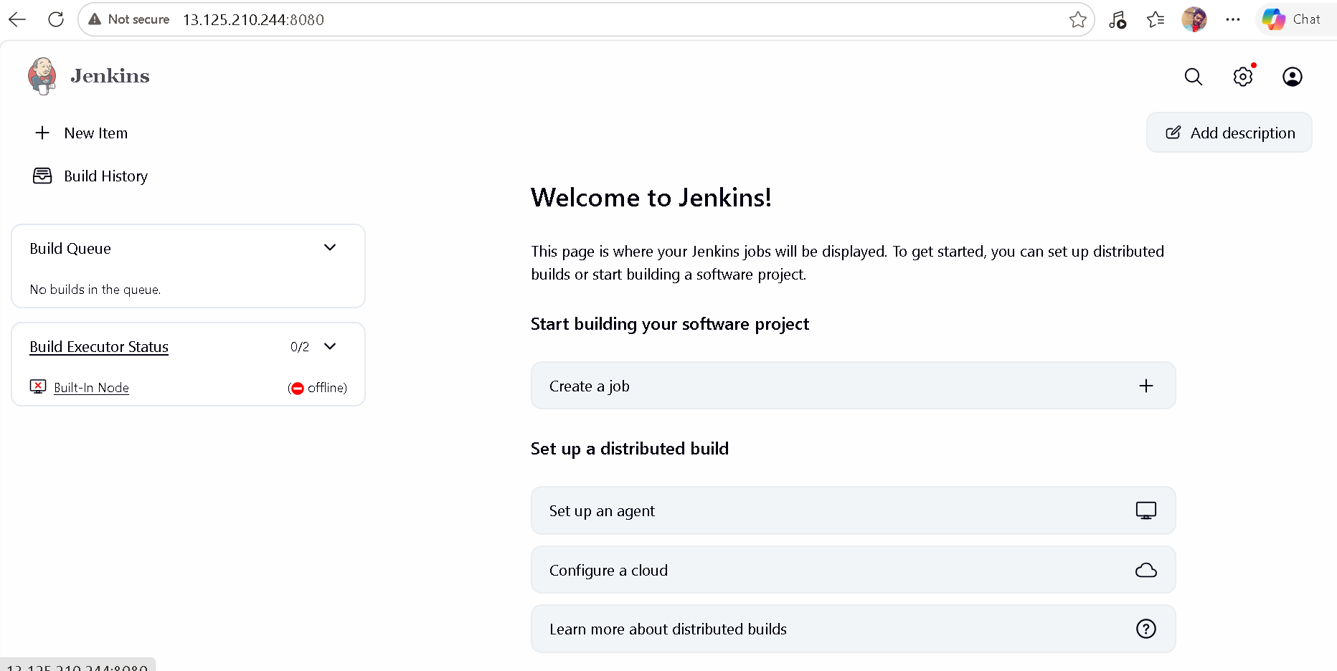

Setup Apache Tomcat on Ubuntu Virtual Machine
1. Start Ubuntu Virtual Machine
First, start the Ubuntu Virtual Machine and open the Terminal.
2. Update Ubuntu
Update the system using:
sudo apt update
sudo apt upgrade -y
3. Install Java
Tomcat requires Java to run. Install Java using:
sudo apt install openjdk-17-jdk -y
Check the Java installation:
java -version
4. Download Tomcat
Move to the /opt directory:
cd /opt
Download the Apache Tomcat package.
5. Extract Tomcat
Extract the downloaded file using:
sudo tar -xvzf apache-tomcat-10.1.46.tar.gz
Rename the extracted folder:
sudo mv apache-tomcat-10.1.46 tomcat
6. Give Permission
Give execute permission to the Tomcat scripts:
sudo chmod +x /opt/tomcat/bin/*.sh
7. Start Tomcat
Start the Tomcat server using:
sudo /opt/tomcat/bin/startup.sh
If the message "Tomcat started" appears, the server has started successfully.
8. Test Tomcat
Open a web browser and enter:
http://localhost:8080
The Apache Tomcat welcome page will appear.

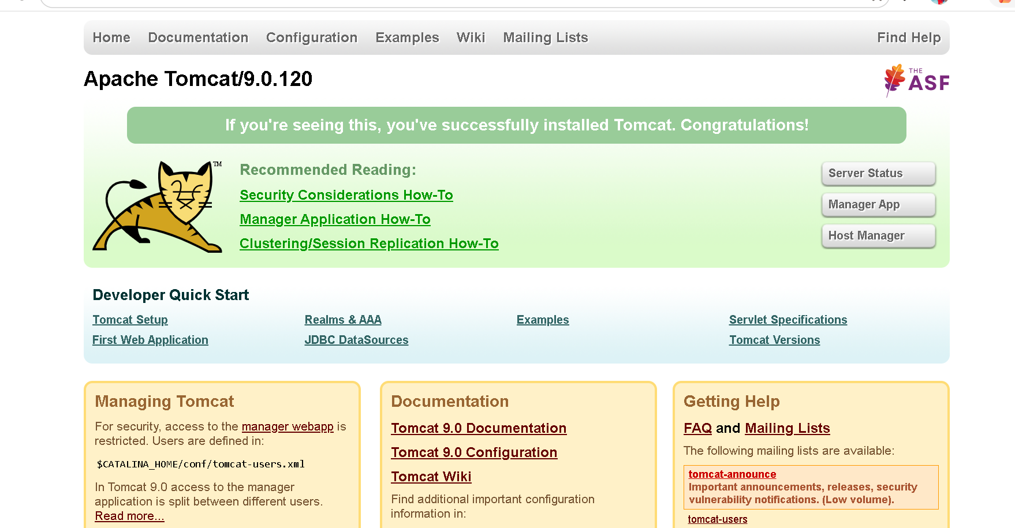

3 Setup Docker Desktop on your local windows ?

Setup Docker Desktop on Local Windows
- Open a web browser.
- Go to the official Docker website.
- Download Docker Desktop for Windows.
- Run the downloaded installer.
- Accept the installation options.
- Click Install.
- Wait for the installation to complete.
- Restart your computer if required.
- Open Docker Desktop.
- Accept the Docker terms and conditions.
- Wait until Docker Desktop starts successfully.
- Open Command Prompt.
- Type:
docker --version
- Press Enter.
- If the Docker version is displayed, Docker Desktop is installed successfully

